WEB DEVELOPMENT INTERNSHIP.

LEVEL 1:

TASK 1: index.html file

<!DOCTYPE html>

<html lang="en">

<head>

    <meta charset="UTF-8">

    <meta name="viewport" content="width=device-width, initial-scale=1.0">

    <title>my portfolio</title>

    <link rel="stylesheet" href="Style.css">

</head>

<body>

    <div class="main">

        <div class="navbar">

            <img src="logo.jpg" class="logo">

            <ul>

                <li><a href="#">HOME</a></li>

                <li><a href="#">ABOUT</a></li>

                <li><a href="#">SKILLS</a></li>

                <li><a href="#">PROJECT</a></li>

                <li><a href="#">RESUME</a></li>

                <li><a href="#">CONTACT</a></li>

            </ul>

        </div>

<div class="info">

<h3>hi, I'm <span>Samruddhi</span>.</h3>

<h1><span>W</span>EB <span>D</span>ESIGNER</h1>

<h3>WEBb designer and developer from yavatmal,maharashtra,

    I create<br>websites  to do business do better<br>online.</h3>

    <a href="#">Hire Me</a>

       </div>

       <div class="image">

        <img src="pic.jpg" class="pic"

       </div>

    </div>

</body>

</html>

TASK 1: style.css file

*{

    margin: 0;

    padding: 0;

}

.main{

    width: 100%;

    background: url(background.jpg);

    background-position: center;

    background-size: cover;

    height: 100vh;

    position: relative;

    font-family: sans-serif;

}

.navbar{

    width: 86%;

    display: flex;

    margin: auto;

    padding: 15px 0;

    align-items: center;

    justify-content: space-between;

}

.navbar .logo{

    width: 160px;

    cursor: pointer;

    margin-top: -3%;

    margin-left: -2%;

}

ul{

    margin-top: -4%;

}

ul li{

    list-style: none;

    display: inline-block;

    padding: 10px 16px;

}

ul li a{

    font-size: 16px;

    font-weight: bold;

    text-decoration: none;

    color: darkslategray;

    margin-top: -3px;

    transition: .4s ease;

}

ul li a:hover{

    color: rgb(230,104,59);

}

.info{

    margin-left: 7%;

    margin-top: 6%;

}

.info h1{

    font-size: 65px;

    color: rgb(36,32,30);

    .info h3{

        font-size: 18px;

        letter-spacing: 1px;

        line-height: 24px;

    }

}

.info span{

    color: rgb(230,104,59);

}

.info a{

    text-decoration: none;

    color: #fff;

    background: rgb(36,32,30);

    margin: 26px;

    padding: 10px 18px;

    display: inline-block;

    transition: .4s ease;

}

.info a:hover{

background: rgb(59,174,209);

}

.image{

    width: 500px;

    height: 400px;

    position: absolute;

    right: 200px;

    bottom: 0;

}

.image img{

    position: absolute;

    height: 300px;

    left: 50%;

    transform: translate(-55);

    button: 0;

    transmission: left 2s ease

}

.image:hover.pic{

    left:55%;

}

Output:

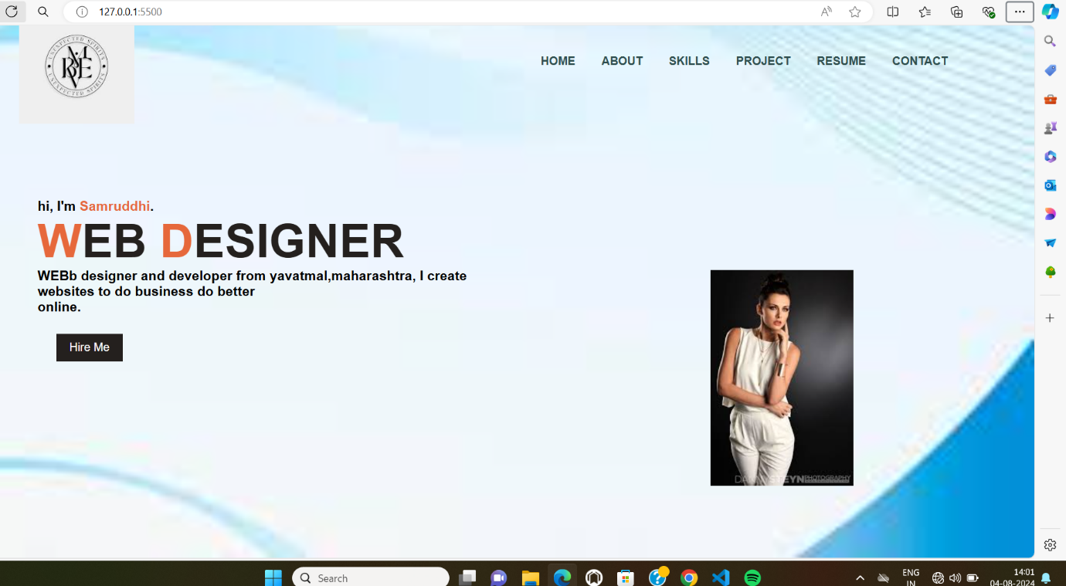

Task 2:index.html file

DOCTYPE html>

<html lang="en">

<head>

<meta charset="UTF-8">

<meta name="viewport" content="width=device-width, initial-scale=1.0">

<title>Document</title>

<link rel="stylesheet" href="style.CSS">

</head>

<body>

<nav>

<h1>COOKIES</h1>

<ul>

<li><a>HOME</a></li>

<li><a>ORDER'S</a></li>

<li><a>VARIETY</a></li>

<li><a>CONTACT</a></li>

</ul>

</nav>

<!--MAIN PAGE-->

<div class="container">

<div class="text">

<h1>CAKE'S.</h1>

<p>Soft and crisp by COOKIE'S<br>

Softness that fall in love with cakes...</p>

<button>View More</button>

</div>

<img src="cake.jpeg" alt="">

</div>

</body>

</html>

TASK 2: CSS file

*{

margin: 0%;

padding: 0%;

}

body{

background-color: black;

color: white;

}

nav{

display: flex;

justify-content: center;

justify-content: space-around;

margin-top: 26px;

}

ul{

display: flex;

list-style: none;

}

nav h1{

font-size: 35px;

}

ul li a{

margin-inline: 30px;

font-size: 24px;

border-bottom: 3px solid rgb(238,8,8);

border-radius: 3px;

cursor: pointer;

}

ul li a:hover{

border: 2px solid white;

}

img{

width: 45%;

}

.container{

display: flex;

justify-content: center;

justify-content: space-around;

margin-top: 50px;

}

.container .text{

margin-top: 40px;

}

.text h1{

font-size: 120px;

}

.text p{

font-size: 26px;

margin-top: 20px;

}

.text button{

width: 160px;

height: 40px;

background-color: rgb(238,12,12);

color: white;

font-size: 26px;

border: none;

margin-top: 50px;

}

.text button:hover{

background-color: brown;

cursor: pointer;

OUTPUT:

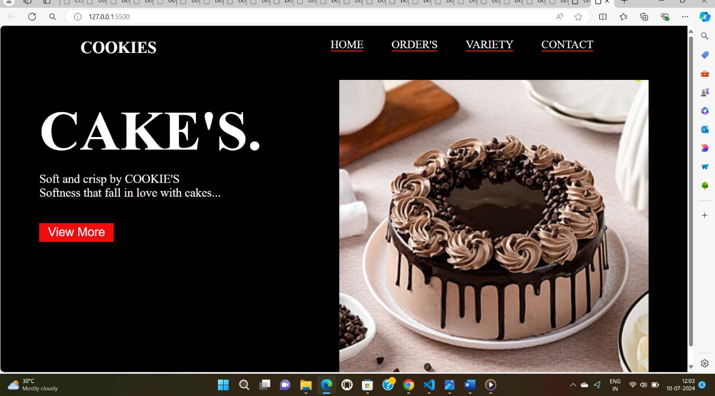

TASK 3: index.html file

<!DOCTYPE html>

<html lang="en">

<head>

    <meta charset="UTF-8">

    <meta name="viewport" content="width=device-width, initial-scale=1.0">

    <link rel="stylesheet" href="style.css">

    <title>Calculator</title>

</head>

<body>

    <div class="container">

        <div class="calculator">

            <input type="text" placeholder="0" id="result">

    <button onclick="clrs()">AC</button>

    <button onclick="dle()">DEL</button>

    <button onclick="display('%')">%</button>

    <button onclick="display('/')">/</button>

    <button onclick="display('7')">7</button>

    <button onclick="display('8')">8</button>

    <button onclick="display('9')">9</button>

    <button onclick="display('x')">X</button>

    <button onclick="display('4')">4</button>

    <button onclick="display('5')">5</button>

    <button onclick="display('6')">6</button>

    <button onclick="display('+')">+</button>

    <button onclick="display('1')">1</button>

    <button onclick="display('2')">2</button>

    <button onclick="display('3')">3</button>

    <button onclick="display('-')">-</button>

    <button onclick="display('0')">0</button>

    <button onclick="display('.')">.</button>

    <button class="equal" onclick="calculate()">=</button>

        </div>

    </div>

    <script src="index.js"></script>

</body>

</html>

Style.css file

*{

    margin: 0%;

    padding: 0%;

    box-sizing: border-box;

    font-family: sans-serif;

    font-weight: bold;

    font-size: 22px;

    color: #ff6525;

    background-color: #ecf0f3;

}

.container{

    height: 100vh;

    display: flex;

    justify-content: center;

    align-items: center;

}

.calculator{

border-color: #ecf0f3;

padding: 15px;

border-radius: 30px;

box-shadow: inset 5px 5px 12px #fff,  5px 5px 12px rgba(0, 0, 0,0.14);

display: grid;

grid-template-columns:repeat(4,70px);

}

input{

    grid-column: span 4;

    width: 260px;

    height: 70px;

    background-color: #ecf0f3;

    border: none;

    box-shadow: inset -5px 12px #fff,

                inset 5px 5px 12px rgba(0, 0, 0,0.14);

                border-radius: 30px;

                outline: none;

                font-size: 50px;

                text-align: end;

                margin: 40px auto;

                padding: 10px;

}

input::placeholder{

    color: #ff6525;

}

button{

    width: 48px;

    height: 48;

    background-color: #ecf0f3;

    box-shadow:  -5px -5px 12px #fff,

                 5px 5px 12px rgba(0, 0, 0,0.14);

                border-radius: 50px;

                border:none;

                margin: 8px auto;

}

.equal{

    width: 115px;

    border-radius: 40px;

    margin: 8px 12px;

}

Index.js file

var result = document.getElementById("result");

function display(number){

    result.value += number;

}

function calculate(){

    var final_number = result.value;

    var final_result = eval(final_number);

    result.value = final_result;

}

function clrs(){

    result.value = "";

}

function dle(){

    result.value = result.value.slice(0,-1);

}

OUTPUT:

